R E S T A U R A N T P O S

USER GUIDE

Tablet Point of Sale
Set the tablet up, take orders, send them to the kitchen, take payment, and close the register.

This document contains two guides. Read the one that matches your job — each is complete on its own.
Guide | Who it is for, and what is in it
BOOK ONE — Staff Guide | Everyone who picks up a tablet during service. Signing in, opening a register, taking dine-in and takeaway orders, sending them to the kitchen, taking payment, and what to do when a message appears.
BOOK TWO — Manager Guide | Whoever sets the system up and keeps it running. Preparing the Odoo server, registering and connecting tablets, printers, who is allowed to do what, and the jobs that can only be done in Odoo.

TIP If a tablet has never been used before, start with Book Two. Nothing in Book One is possible until the tablet has been registered and connected.

BOOK ONE — STAFF GUIDE
Open the register, take the order, feed the kitchen, take the money.

Contents of Book One
Part | Steps
PART 1 Signing In | 1 Sign in · 2 Home, your profile and signing out
PART 2 Opening the Register | 3 Open or continue a session · 4 Choose the order type
PART 3 Taking an Order | 5 Seat a dine-in table · 6 Start or resume a takeaway · 7 Add products · 8 Change a line · 9 Switch the price list · 10 Read the totals · 11 Two tablets, one order
PART 4 Sending Work to the Kitchen | 12 The Kitchen Bill screen · 13 Print Add-ons or Print Full Order · 14 Name a takeaway and set its time
PART 5 Taking Payment | 15 Unlock payments · 16 Choose a method and take the money · 17 What happens after you tap Pay · 18 What a closed order looks like
PART 6 Managing Takeout Orders | 19 The takeaway list · 20 Reopening an order
PART 7 When Something Goes Wrong | 21 How the app behaves when the network drops · 22 Message by message
QUICK REFERENCE | Where things are · Things to remember

About This Guide
This is the guide for everyone who takes orders. It follows a shift in order: sign in, open a register, take orders, print to the kitchen, take payment, close up.
The app is a front end for your Odoo server. Every order, product, price and payment lives in Odoo — the tablet is how you reach it. So the tablet is fast at the things a busy floor needs, and deliberately cannot do the rest. Where a job belongs in Odoo, this guide says so.
There are no user roles. Everyone who can sign in sees the same screens and the same buttons. The one thing that may stop you is the payment PIN — see Step 15.
TIP Setting a tablet up, adding printers and changing what is on the menu are all in Book Two. If something in this guide is missing from your screen, that is usually where the answer is.

Your Shift at a Glance
▪ Before service — sign in, then open a register from POS Register
▪ Seating guests — Dine In, pick the table, and start adding items
▪ Phone and counter orders — New Takeout Order, name it, and set a collection time
▪ As items are ordered — tap Kitchen Bill and print, so the kitchen has the ticket
▪ When guests are ready — tap Pay Now, take the money, and the receipt prints itself
▪ End of service — Close the register, then sign out

PART 1 SIGNING IN

Step 1 Sign In
The sign-in screen greets you with Welcome Back and “Sign in to continue.” Fill in two fields and tap Login:
Field | What to put in it
Username or Email | Your Odoo login. The field prompts you with “Enter username or email.”
Password | Your Odoo password. Tap the eye icon beside the field to check what you typed.

The two pills in the top-left corner, EN and عربي, switch the whole app between English and Arabic. The choice sticks, and it is also available later on your Profile screen.
The Autofill Credentials switch fills both fields from the last successful sign-in on this tablet. Turning it off clears both fields again.
What you see | What it means
“Username is required” / “Password is required” | A field is empty. Nothing has been sent to the server yet.
“Invalid credentials. Check your username and password.” | The server rejected the login. Check the username, the password, and that you are on the right database.
Connection problem with Cancel and Retry | The tablet cannot reach the server. See Part 7.

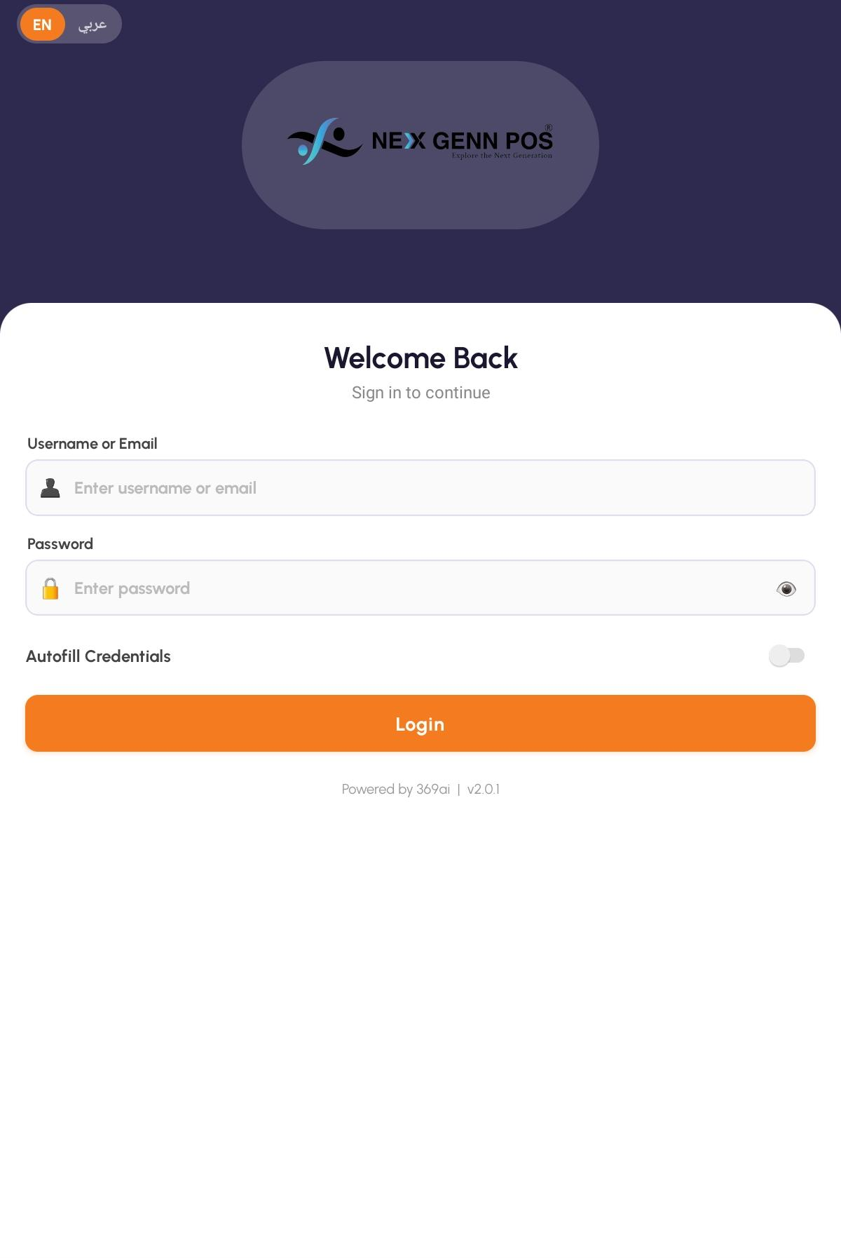
The sign-in screen — the language pills, both fields and the Autofill switch

Step 2 Home, Your Profile and Signing Out
After signing in you land on Home. There are three tabs along the bottom: Home, Profile and Logout.
Home has one thing that matters during service — the big orange Take Orders card, marked “Dine-in, Takeaway & more.” That is the way in to every order. Below it, Our Specials shows your product categories; tapping one browses the catalogue, which is useful for checking a price but is not part of taking an order.
Profile is read-only. It shows your name, company and the Account Details card — User ID, Login, Database, Partner and Company — which is exactly what a support call will ask you for. The language pills are repeated here.
Logout asks “Are you sure you want to logout?” and returns you to the sign-in screen.
TIP Signing out does not close the register. The session stays open in Odoo and the next person to sign in on any tablet can carry on with it.

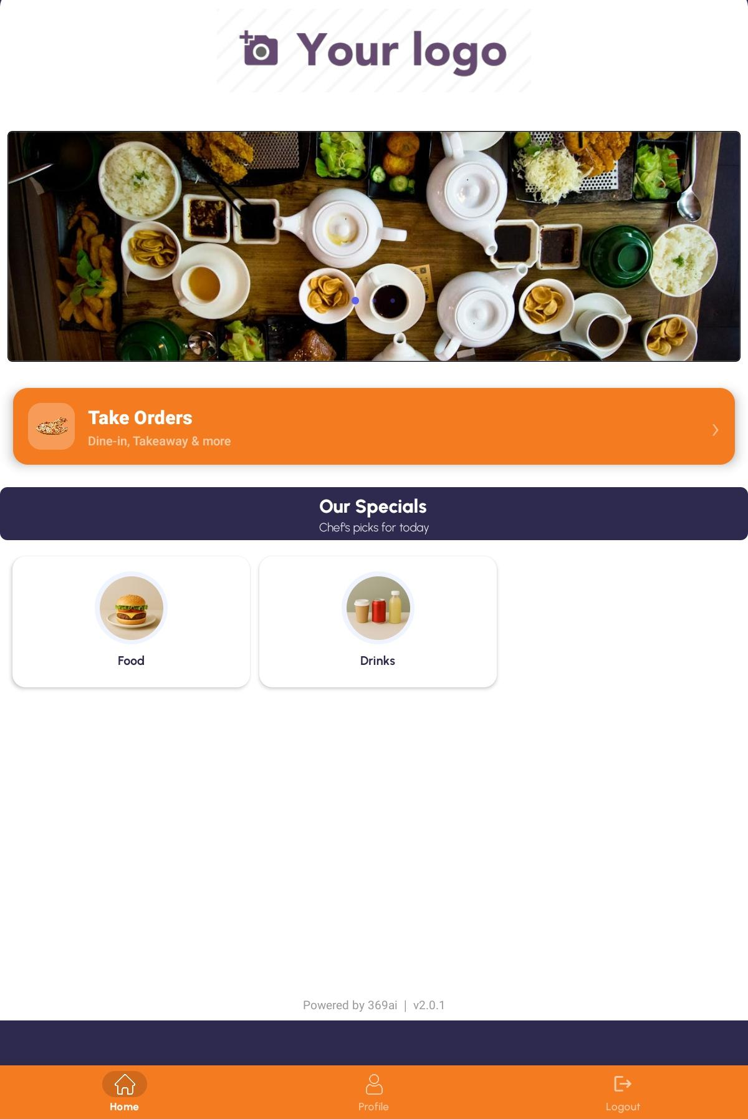
Home — the Take Orders card and the Our Specials grid

PART 2 OPENING THE REGISTER

Step 3 Open or Continue a Session
Tap Take Orders to reach POS Register. The screen has two sections, each with a count badge.
Section | What is in it, and what to do
Active Sessions | Registers already open. Each card shows Session #, the User who opened it, Opened At and the Opening Amount. Tap Continue Selling to carry on, or Close to end the session.
Available Registers | Registers with no session running, marked “Tap below to open this register and start a new selling session.” Tap Open Register.

Opening one confirms with Register Opened and the new session number. Closing asks “Are you sure you want to close this register?” first, then confirms with Register Closed.
IMPORTANT Close ends the session; it does not count the cash. There is no cash-count step on the tablet. The closing balance and the day's reconciliation are done in Odoo.

If the list will not load you get “Failed to load POS registers or sessions” with a Retry button; if there is genuinely nothing set up, you get “No registers found.” The two are shown differently on purpose, so a network fault never looks like an empty shop.
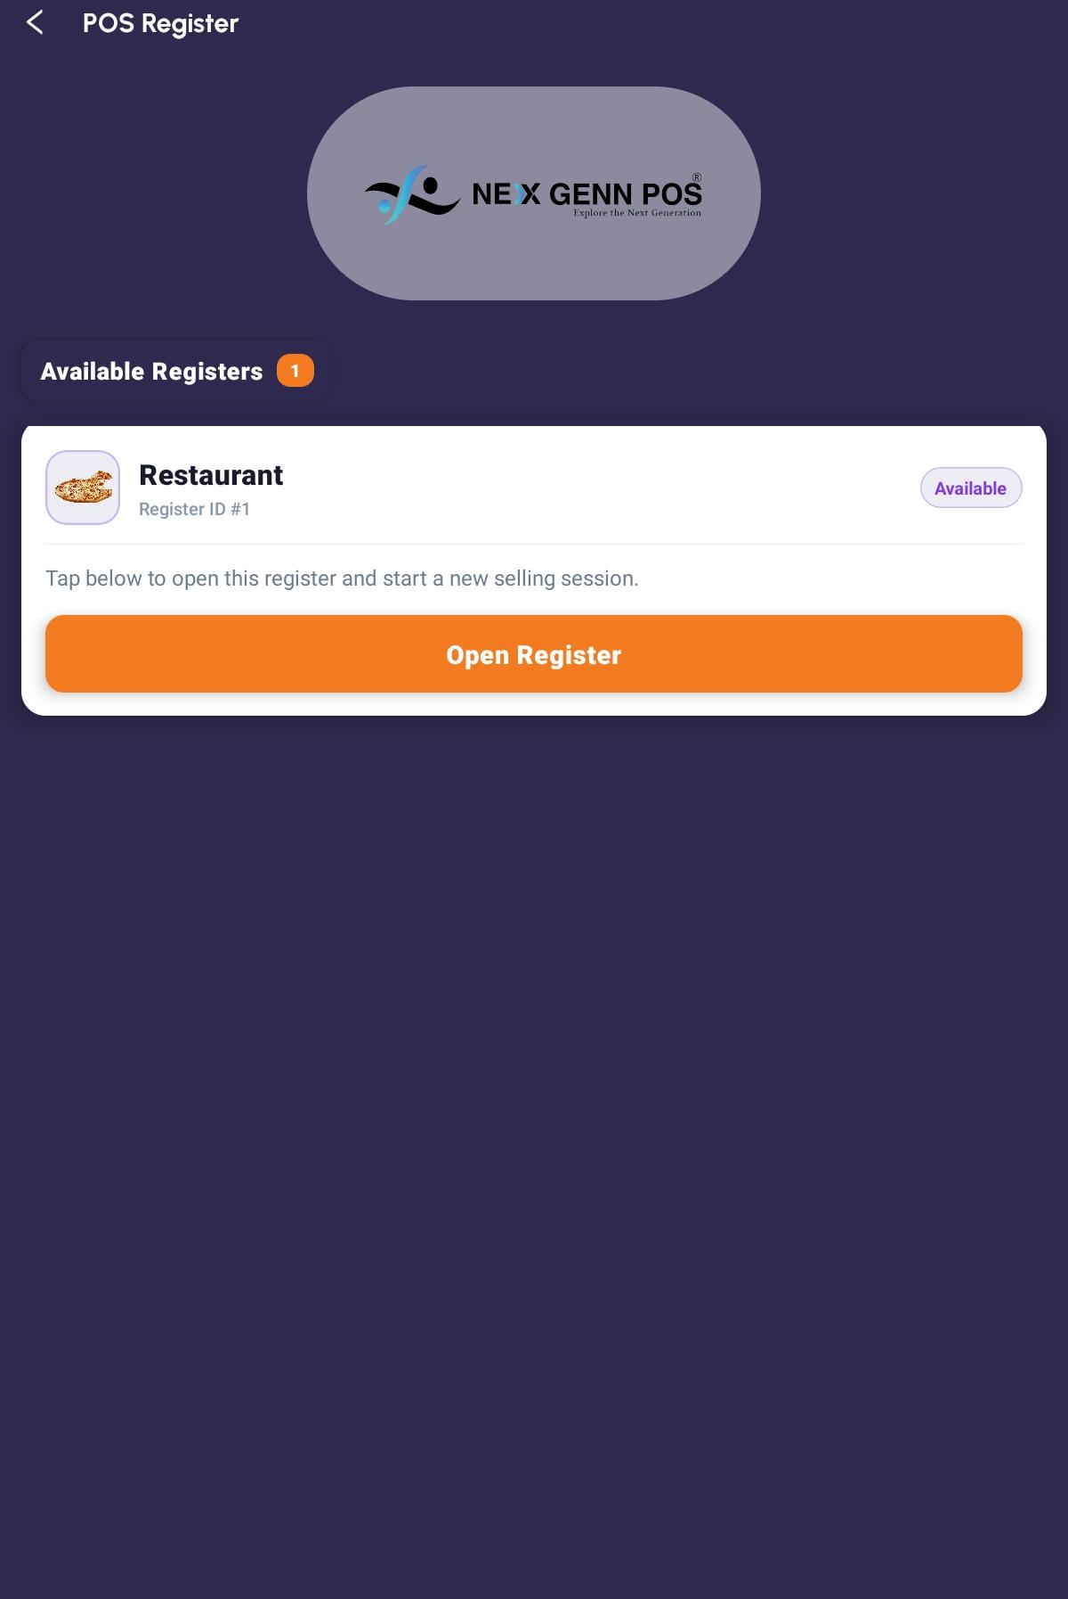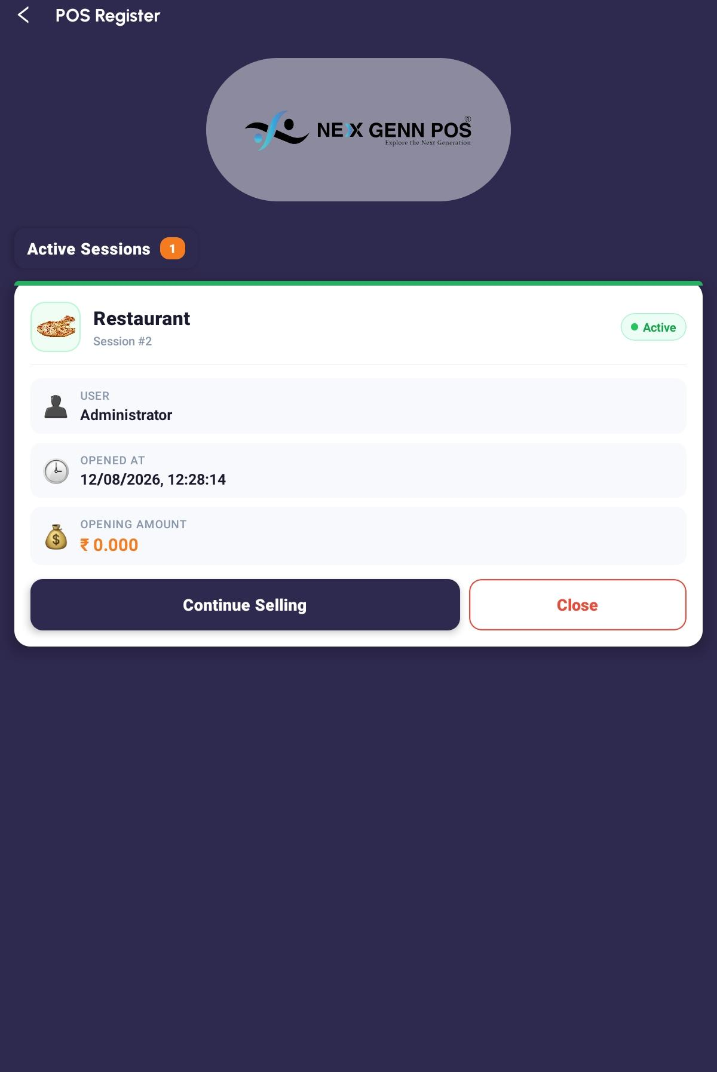
POS Register — one Active Session and one Available Register

Step 4 Choose the Order Type
Continue Selling takes you to Choose Order Type, headed “How would you like to serve today?” There are three cards:
Card | What it does
Dine In | Opens the floor plan so you can pick a table. Marked “Seat guests at a table and take orders.”
New Takeout Order | Creates a takeaway order straight away and drops you into the register. Marked “Create a fresh takeaway order for pickup.”
Takeout Orders | Opens the list of takeaway orders so you can reopen one. Marked “View and manage existing takeout orders.”

IMPORTANT There is no separate Delivery order type. Delivery and aggregator orders are taken as takeaway, and priced by switching to the second pricelist on the register — see Step 9.

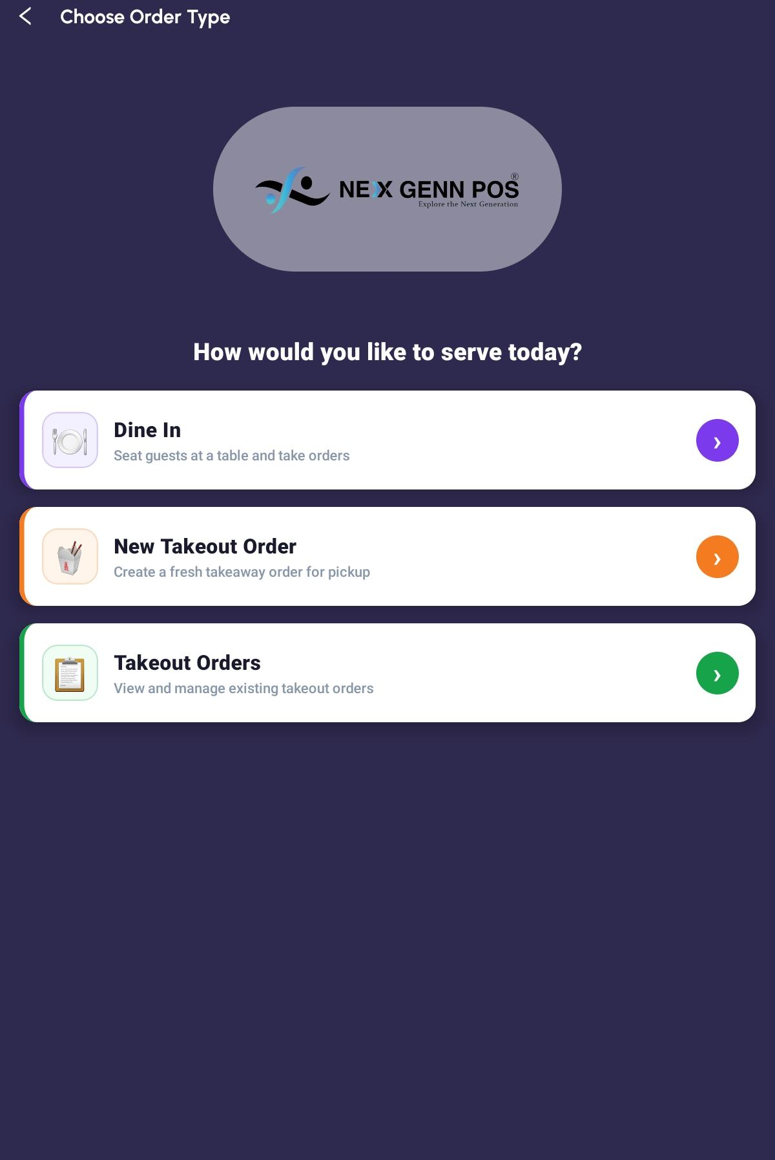
Choose Order Type — the three cards

PART 3 TAKING AN ORDER

Step 5 Seat a Dine-In Table
Dine In opens Select Table. Along the top is one pill per floor; if your server has no floors set up you get a single tab called Main Floor. Under that is a running count: Occupied, Available and Total.
Each table is a square card showing its number and a seat count. The colours are worth learning:
What you see | What it means
White card, green bar | Free. Tapping it starts a new order.
Purple card, orange bar | Occupied. Tapping it reopens the order already running on that table.

Tap a table and the app either reopens the existing order or creates a new one, then takes you to the register.
TIP A table only counts as Occupied once something has been rung onto it. A table with an order started but still empty shows as Available. That is deliberate — an abandoned blank order should not lock a table for the rest of service.

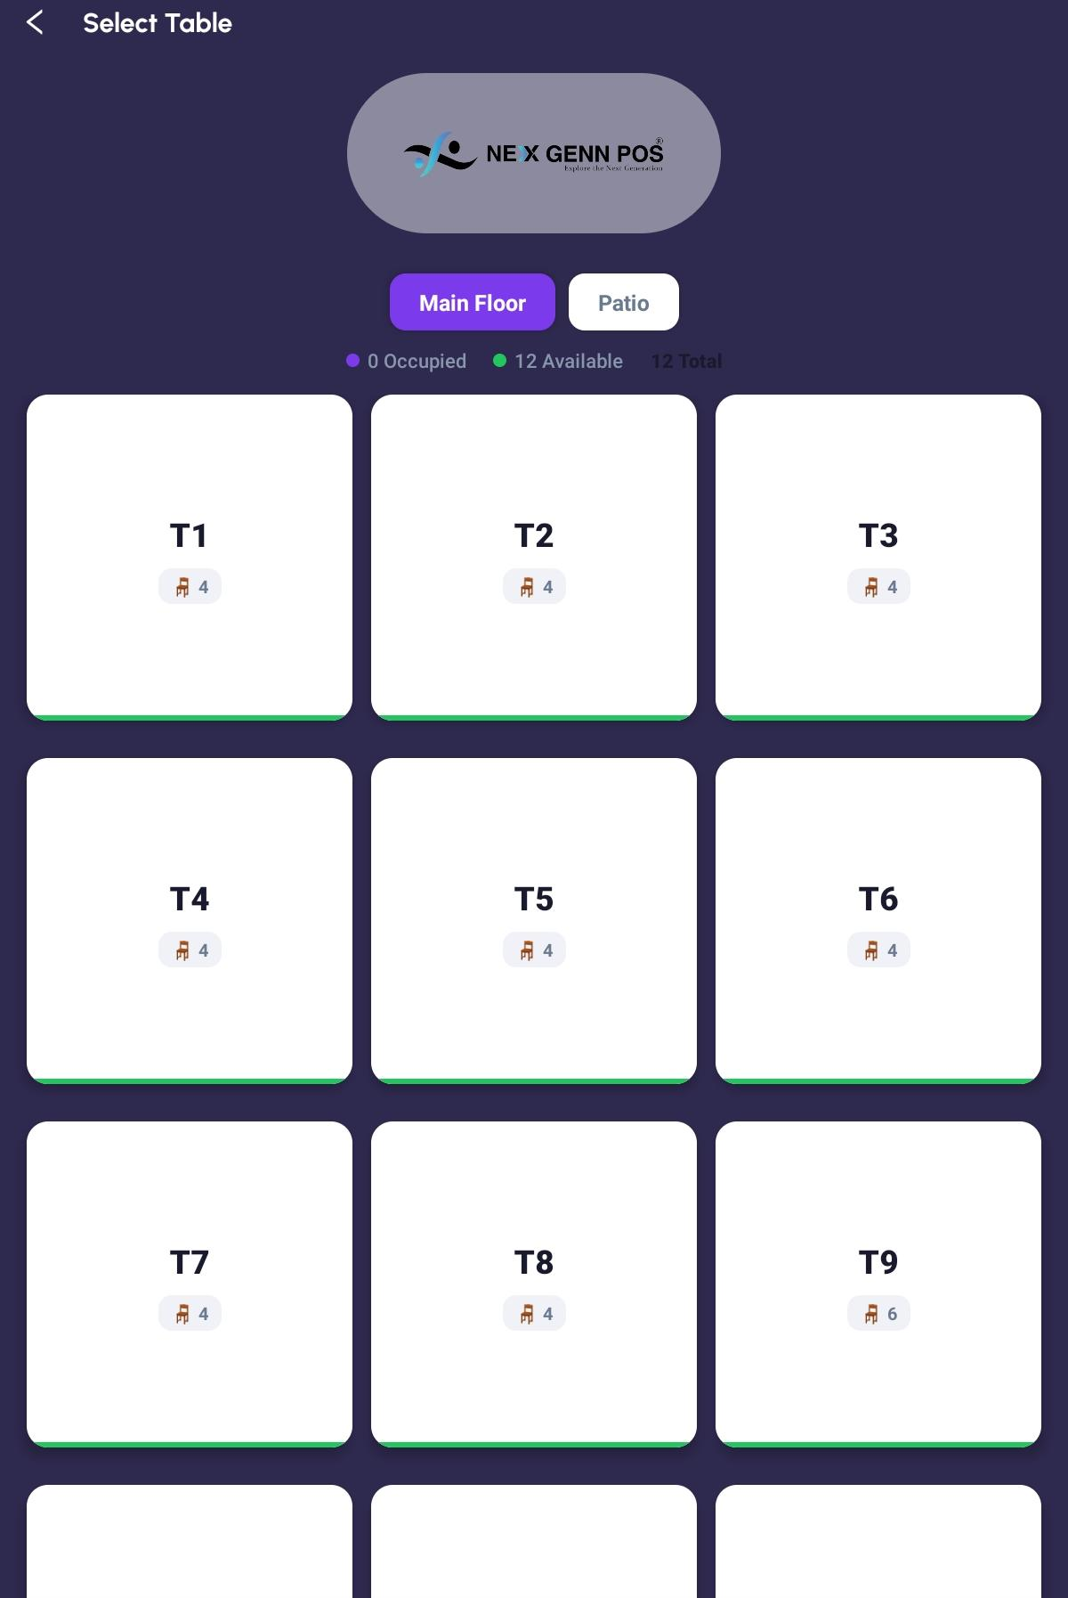
Select Table — floor tabs, the counters and a mix of free and occupied tables

Step 6 Start or Resume a Takeaway
New Takeout Order creates the order immediately — you will see “Creating order…” for a moment — and puts you straight into the register. You name it and set its collection time later, when you send it to the kitchen.
Takeout Orders opens the list instead, so you can pick up an order someone started earlier. That screen is covered in Part 6.

Step 7 Add Products
The register is the screen you will spend the shift on. Its title is Register; beneath it sits the order reference, and on the right the name of whoever is serving.
An empty order reads No items yet with “Tap 'Add Products' to get started.” To add something:
▪ Tap + Add Products. The product picker opens over the register.
▪ Narrow the list with the category pills along the top — the first is Show All — or type in Search Products.
▪ Tap the orange + on a product tile. The Add Item popup opens.
▪ Set the Quantity with the round − and + buttons, and add a Note if the kitchen needs one — the field suggests “e.g. no sugar, extra ice…”
▪ Tap + Add. A small Added to Cart chip flashes to confirm.
▪ When you have everything, tap Go to Register at the bottom of the picker.
TIP An item added with a note always becomes its own line, so two guests can have the same dish cooked differently. An item added without a note merges into the matching line and just raises its quantity.

Prices on the tiles already include tax, so what you see on the tile is what the guest pays for one of them.

Step 8 Change a Line
Each line on the register shows its number, the product, the unit price with each, a − / quantity / + stepper and the line total. Any note appears under the product name.
To do this | Do this
Change the quantity | Tap − or + on the line.
Remove the line | Tap − when the quantity is 1. The line goes immediately.
Add or edit a note | Tap the line to open Item Options, then type under Notes.
Apply a discount | Tap the line, then a tile under Discount. The choices are 10%, 20%, 30%, 40% and 50%.
Take a discount off | Tap the line, then Remove Discount. It only appears when one is applied.

A discounted line shows the original price struck through, an arrow, and the new price in green, with a red badge showing the percentage — so the guest can see what they were given.
IMPORTANT Removing a line has no confirmation. One tap of − at quantity 1 and it is gone. There is also no whole-order discount and no free-typed percentage — the five tiles are the only options, and they apply to one line at a time.

Step 9 Switch the Price List
When your server has a second pricelist set up, a two-button row appears at the top of the register: DINE IN PRICE and APPLICATION PRICE. Tap either one to re-price the whole order. A Pricelist changed message confirms which list you are now on.
Use this for delivery-partner or aggregator orders that are billed at a different rate from your walk-in menu.
IMPORTANT Switching the price list clears every discount you have applied to that order. Set the price list first, then apply discounts — not the other way round.

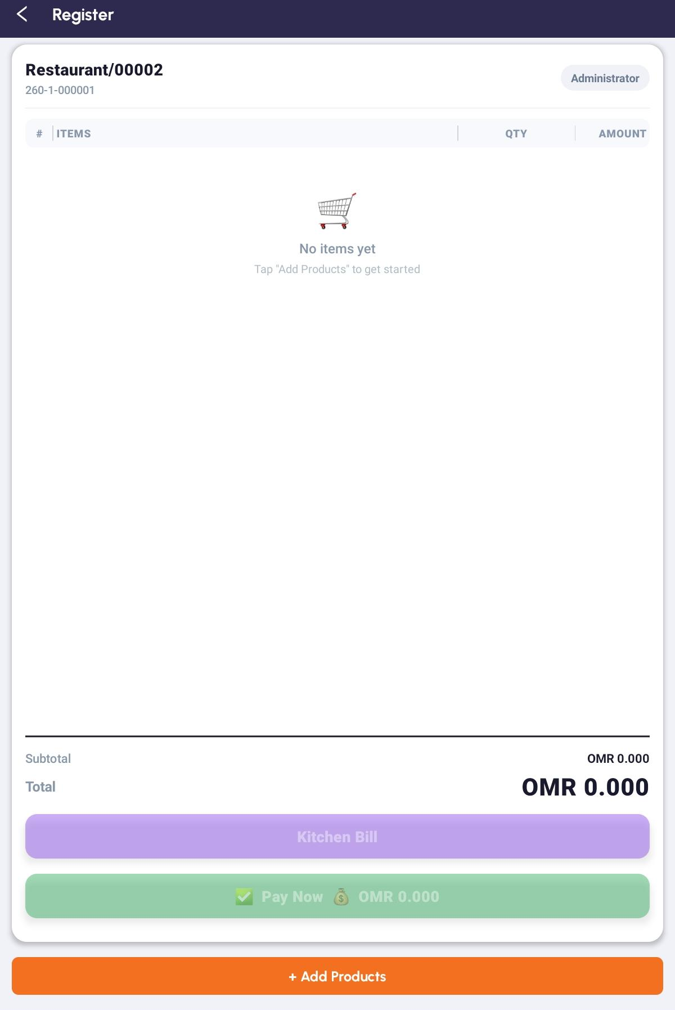
The register — the price-list row, several lines and a discounted line

Step 10 Read the Totals
Line | What it is
Subtotal | The order before tax.
Taxes | The tax on the order. The row is hidden when there is no tax to show.
Total | What the guest pays. This is the figure repeated on the Pay Now button.

Amounts are shown to three decimal places throughout, in the currency your Odoo company is set to.

Step 11 Working on One Order From Two Tablets
While the register is open the tablet re-reads the order from the server every few seconds, so two people working the same table stay in step. The rules are simple and worth knowing:
▪ The server wins. If a colleague changed a quantity, a note or a discount, their version replaces yours.
▪ A line a colleague added appears on your screen.
▪ A line a colleague removed disappears from yours.
▪ An item you have only just tapped is never wiped by a refresh before it has reached the server.
TIP If a screen ever looks out of date, leave it and come back — every list in the app reloads when you return to it.

PART 4 SENDING WORK TO THE KITCHEN

Step 12 The Kitchen Bill Screen
Tap Kitchen Bill on the register. For a dine-in order you go straight to the preview. For a takeaway, two short questions come first — see Step 14.
The preview shows the order, its TABLE, its SERVER and its item count, and splits the order into two sections:
Section | What is in it
New Items | Only what has been added since the last time you printed. When there is nothing new it reads “No new items since last print.”
Full Order | Everything on the order, from the beginning.

Step 13 Print Add-ons or Print Full Order
Button | When to use it
Print Add-ons | The normal choice for a second and third round. Prints only what is under New Items, so the kitchen is not handed the whole table again.
Print Full Order | The first ticket, or any time the kitchen has lost the earlier one and needs the lot.

A successful print confirms with KOT Printed and “Kitchen Order Ticket sent to printer.” If there is nothing to send you get “Nothing to print.”
TIP Items are routed to kitchen printers by their product category, so a grill order and a bar order land in the right places from one tap. If a ticket comes back saying no printer matched, that is a setup job — Book Two, Step 8.

Step 14 Name a Takeaway and Set Its Time
A takeaway needs a name and a collection time so the kitchen knows who it is for and when it is wanted. Tapping Kitchen Bill on a takeaway order asks for both.
First, Edit Order Name. Type the customer's name — the field suggests “e.g. John” — or tap one of the recent names shown beneath. Tap Apply.
Then, Select Date & Time. Pick a day from the row of date chips, then a slot. Slots run in twenty-minute steps and are grouped by part of the day, under headings such as Morning, Afternoon and Evening. Slots that have already passed today are not offered. If the day has nothing available you will see “No slot available for this day.” Tap Confirm and the kitchen preview opens.
TIP The times offered come from the opening hours attached to your takeaway preset in Odoo. If the choices look wrong, that schedule is what to fix — Book Two, Step 2.

PART 5 TAKING PAYMENT

Step 15 Unlock Payments
Look at the pay button. It reads Pay Now with the order total, and it carries a small padlock when payment is locked and a tick when it is not.
Tap it while locked and you are asked for the PIN: “Enter the PIN to unlock payments for this session.” Type it and tap Unlock. Get it wrong and the box turns red with “Incorrect PIN. Try again.”
A correct PIN opens the payment sheet straight away — you do not have to tap Pay Now a second time — and payment stays unlocked until you leave the register screen.
TIP If Pay Now never asks you for a PIN, no PIN has been set on that register. If a manager changes the PIN during service, the new one works on the very next order — nobody needs to sign out and back in.

Step 16 Choose a Method and Take the Money
The Select Payment Method sheet shows Subtotal, Taxes and Order Total, then a list of the payment methods set up on your server. Tap one; a tick marks it.
For a cash method an Amount Received box appears, pre-filled with the exact total. Type what the guest handed over and the app works out the rest:
What you see | What it means
Change (green) | The guest gave you more than the total. This is what to hand back.
Remaining (red) | Not enough yet. The pay button stays disabled until the full amount is in.

Tap the green Pay button, which shows the amount, to finish.
IMPORTANT An order is settled with one payment method. There is no split payment and no tip entry on the tablet. A guest who wants to split the bill has to be handled in Odoo.

Step 17 What Happens After You Tap Pay
In order: the payment is recorded against the order, the order is marked paid, the cart clears, and the receipt is sent to the printer by itself. A small “Receipt sent to printer” message appears at the bottom of the screen.
Finally Payment Successful confirms “Order has been closed and payment recorded.” Tap OK and you are returned to Home, ready for the next order.
TIP If nothing failed but you saw no receipt message, no receipt printer is configured on that register. That case is kept silent on purpose — plenty of sites run kitchen tickets only.

If anything goes wrong you get Payment Failed with the reason, and the order is left exactly as it was — the cart is not cleared and no receipt prints. That is deliberate: you can read the message, fix the cause and try again without rebuilding the order.
TIP Tapping Pay twice will not charge twice. Each attempt carries its own identifier, so a repeat lands on the same payment rather than creating a second one.

Step 18 What a Closed Order Looks Like
Reopen a paid order — from the table, or from the takeaway list — and it is read-only. + Add Products, Kitchen Bill and Pay Now are all gone, the quantity steppers become plain numbers, and tapping a line no longer opens Item Options.
This is your record of what was sold. To change anything after payment — a refund, a correction, a void — the job goes to Odoo. See Book Two, Step 11.

PART 6 MANAGING TAKEOUT ORDERS

Step 19 The Takeaway List
Takeout Orders opens Takeaway Orders, the only order list in the app. Across the top are three counters: Total Orders, Open and Completed. They are a summary, not filters — tapping them does nothing.
Each card shows the customer name if one was set, the order reference, when it was created, the amount, and where a collection time was chosen, a Takeout time beneath. On the right is a status pill:
Pill | What it means
Open (blue) | Still a draft. Tap it to carry on adding items or to take payment.
Paid (green) | Settled. Opens read-only.
Done (green) | Finished and closed off in Odoo.
Cancelled (red) | Cancelled in Odoo.

If the list cannot load you get Error, the reason, and a Retry button — never a misleading empty screen. A genuinely empty list says No Takeaway Orders.
IMPORTANT This list holds takeaway orders only. There is no dine-in order list — a dine-in order is reached through its table on the floor plan, and once it is paid the table is free and the order is no longer on the tablet.

Step 20 Reopening an Order
Tap any card to open it in the register. An Open order is fully editable: add items, change quantities, print another kitchen ticket, take payment. A paid one opens read-only, as described in Step 18.
The list refreshes every time you come back to it. There is no pull-to-refresh, and no search or date filter — if you are hunting for an old order, Odoo is the place to look.
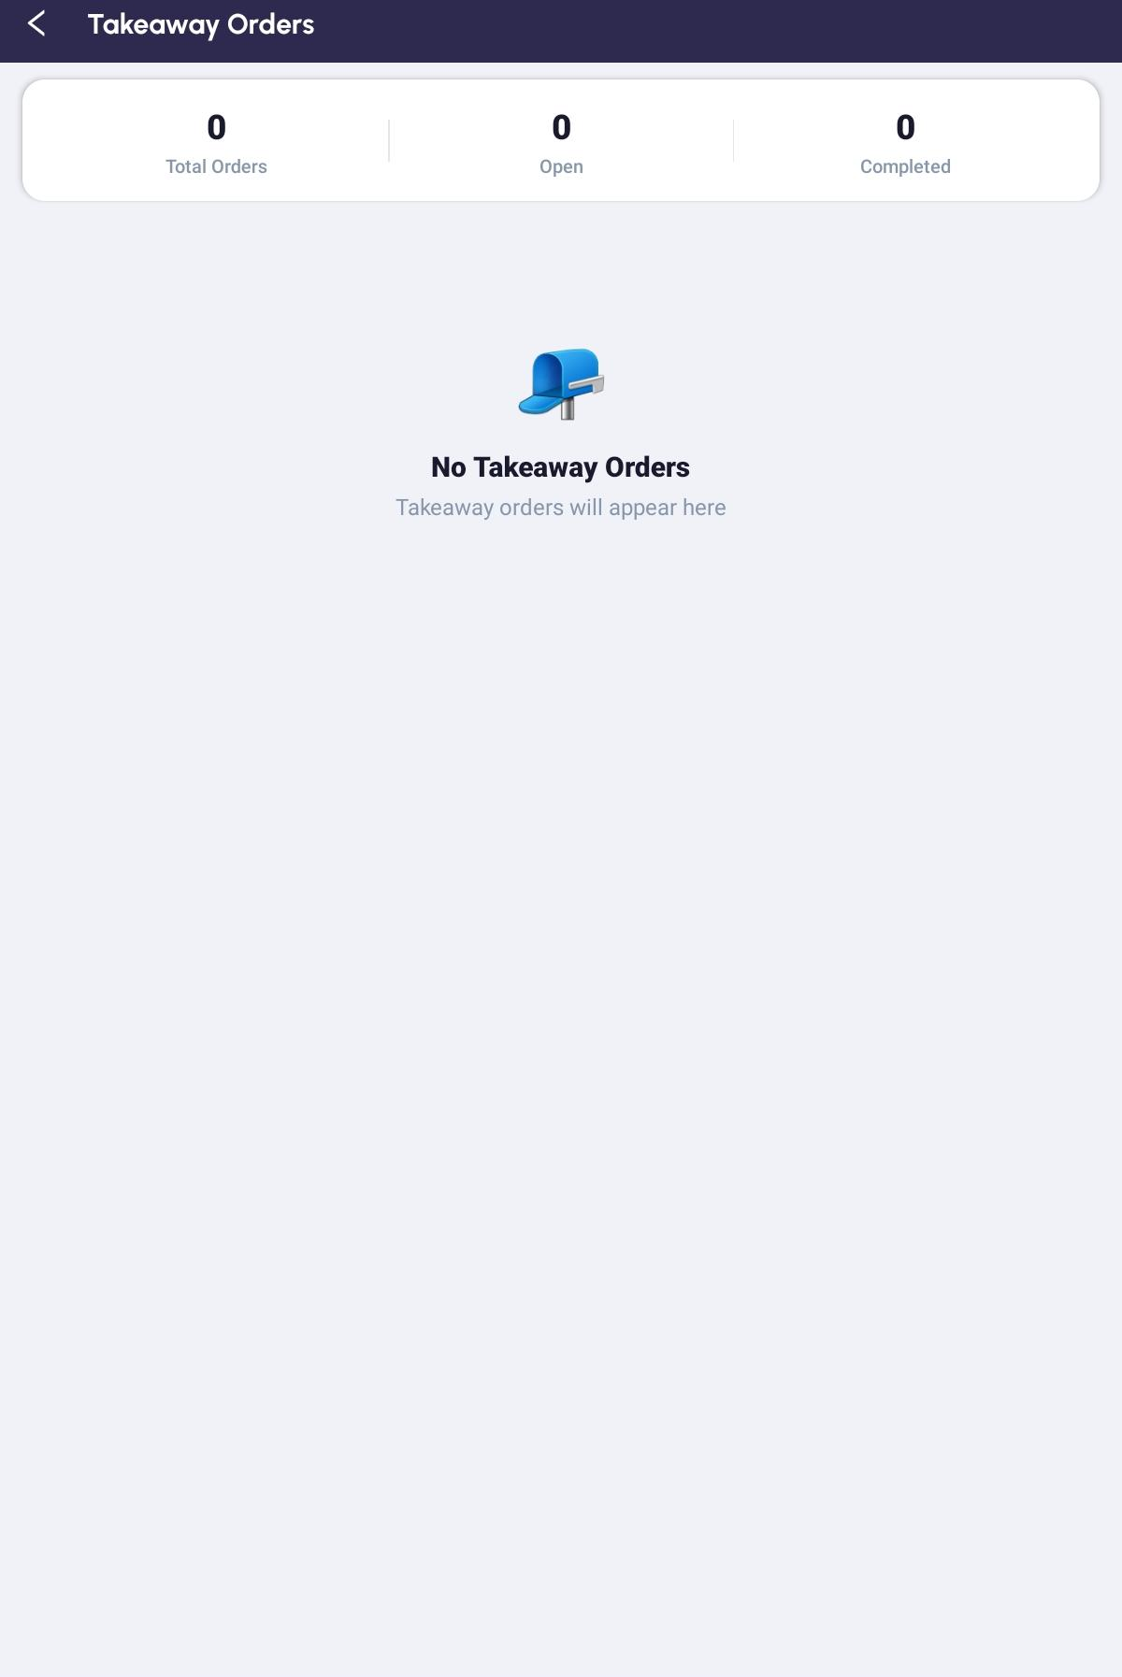
Takeaway Orders — the counters and the status pills

PART 7 WHEN SOMETHING GOES WRONG

Step 21 How the App Behaves When the Network Drops
The app does not shout at the first dropped packet. A failed request is retried quietly, several times over about twelve seconds — long enough to ride out a cloud server waking up or a moment of Wi-Fi weakness. Most of the time nobody notices.
The Connection problem box, with Cancel and Retry, is shown for the sign-in request. Elsewhere a request that never succeeds simply fails quietly, and the screen reloads when you leave it and come back.
What you see | What it means
Cannot reach server | The tablet cannot get to the server at all. Check the tablet's Wi-Fi first, then the server.
Server not responding | The server was reached but did not answer in time. Usually a slow or overloaded server rather than the tablet.

TIP Retry sends the same request again, once. If it fails twice, stop tapping and check the network — the answer is not going to change.

Step 22 Message by Message
The messages you are most likely to meet during service, and what to do about each. Anything to do with setting a tablet up is in Book Two, Step 12.
Registers and orders
What you see | What it means | What to do
Failed to load POS registers or sessions | The register list could not be read. | Tap Retry. If it persists, check the network.
No registers found | The list loaded and is genuinely empty. | A register has to be set up in Odoo.
Could not open/create order for table. | The table could not be opened. | Go back and tap the table again.
Odoo Error / Failed to sync with server | A change to a line did not reach the server. | Check the line is right — the screen refreshes itself — and redo it if not.

Payment
What you see | What it means | What to do
Incorrect PIN. Try again. | Wrong payment PIN. | Ask the manager. A PIN changed in Odoo takes effect on the next order.
Payment Failed / Select Payment Method | No method was chosen. | Tap a method in the list, then Pay.
Payment Failed with a message from the server | The server refused the payment. | The order is untouched. Read the message, fix the cause, pay again.
Receipt not printed | The receipt failed after a successful payment. | The payment went through. Get the printer looked at; do not take the money again.

Kitchen printing
What you see | What it means | What to do
Nothing to print. | There are no new items, and nothing on the order. | Add an item first.
No printer matched these items. | No kitchen printer covers the categories on this order. | A setup job — Book Two, Step 8.
Timeout reaching… | The printer did not answer. | Check the printer is switched on and connected.
Module Not Installed or Print Error | Something on the server side is missing or refused. | Pass the message to whoever manages the server.

QUICK REFERENCE — STAFF

Where Things Are
Screen | How to get there
POS Register | Home → Take Orders.
Choose Order Type | POS Register → Continue Selling.
Select Table | Choose Order Type → Dine In.
Register (the order) | Tap a table, or New Takeout Order, or a card in the takeaway list.
Kitchen Bill | Register → Kitchen Bill.
Takeaway Orders | Choose Order Type → Takeout Orders.
Profile | The middle tab at the bottom.

Things to Remember
▪ − at quantity 1 removes the line, with no confirmation.
▪ Switching the price list clears every discount on the order. Set the price list first.
▪ Add a Note when the kitchen needs to cook it differently — it becomes its own line.
▪ Payment Failed leaves the order intact — read the message and pay again rather than rebuilding it.
▪ Receipt not printed after a successful payment is a printer problem, never a reason to charge again.
▪ Tapping Pay twice does not charge twice.
▪ Close ends the session; it does not count the cash.
▪ No network, no orders. There is no offline mode.
▪ If a screen looks stale, leave it and come back — every list reloads on return.
Open the register, seat the table, feed the kitchen, take the money. Everything else lives in Odoo.

— End of Book One —
Alphalize | Restaurant POS User Guide

BOOK TWO — MANAGER GUIDE
Prepare the server, connect the tablets, set up the printers, and know what only Odoo can do.

Contents of Book Two
Part | Steps
PART 1 Preparing the Server | 1 Check the modules · 2 Name things so the app can find them
PART 2 Setting Up a Tablet | 3 Register the tablet in Odoo · 4 Connect the tablet · 5 Pair by QR · 6 Getting back to Device Setup later
PART 3 Printing | 7 How the app decides where to print · 8 Set the printers up in Odoo · 9 What each document is
PART 4 Controlling Access | 10 The three controls
PART 5 What Belongs in Odoo | 11 Jobs the tablet cannot do
PART 6 When a Tablet Will Not Set Up | 12 Setup messages, and what they mean
QUICK REFERENCE | New site checklist · Things to remember

About the Manager's Job
You run the system. You get the Odoo server ready, you decide which tablets are allowed to connect, you set up the printers, and you do the jobs the tablet deliberately cannot — refunds, reports and the cash reconciliation.
Almost all of it is done in Odoo on a computer. The tablet has no settings screen: there is nothing to configure on the device itself beyond the one-time connection in Part 2.
IMPORTANT Work through Parts 1 and 2 in order on a new site. Naming things correctly (Step 2) before you connect a tablet saves a long hunt for features that appear to be missing.

PART 1 PREPARING THE SERVER

Step 1 Check the Modules
The app needs a small set of modules installed on your Odoo server. Without them the matching feature is simply missing, and the app will tell you so when someone tries to use it.
Module | What it gives you | Without it
device_login_config | Device approval, the Device Registry screen and the pairing QR code. | No tablet can be set up at all.
pos_kot_print_online | Kitchen tickets, the printer records and category routing. | Nothing prints.
pos_payment_pin | The PIN that unlocks payment. | The PIN gate is off; anyone can take payment.
pos_idempotent_create | Protection against a double tap creating two payments. | Payments still work, but a retry can duplicate one.

The app is written to survive a missing module rather than break: it checks which fields your server actually has and quietly drops the ones it does not, instead of failing the whole request. So a stock Odoo will run the app — just with less of it.

Step 2 Name Things So the App Can Find Them
This is the step people miss, and it causes the strangest faults. Several features are matched by name, not by a setting you tick. Get the names wrong and the feature silently disappears.
In Odoo | The rule | If you get it wrong
Dine-in preset | Its name must contain dine. | Dine-in orders are created with no preset.
Takeaway preset | Its name must contain take. | Takeaway orders never appear in Takeout Orders.
Second pricelist | Its name must contain application (or your delivery partner's name) for the price toggle to appear. | The price toggle is not shown at all.
Floors | Any floor whose name contains my company is hidden from the tablet. | A floor you expected is missing.
Products | Available in POS must be ticked. | The product is not in the grid or the search.

IMPORTANT The price toggle only appears when your server has two pricelists — the everyday one and the one whose name contains application. With a single pricelist there is nothing to switch between, so the row is hidden.

The takeaway preset also carries the opening hours that produce the collection-time slots staff see in Book One, Step 14. If the offered times look wrong, that schedule is what to fix.

PART 2 SETTING UP A TABLET

Step 3 Register the Tablet in Odoo
Open Device Registry in Odoo and create a record for the tablet. Each device carries a Device ID, a Device Name and a Status. The status is your on/off switch for that tablet:
Status | What it means
Pre-Registered | You have created the record but the tablet has not connected yet. This is the state a new device needs to be in before setup will work.
Active | The tablet has connected and is in service.
Blocked | Access revoked. The tablet cannot sign in, whoever is holding it and whatever password they know.

The record also shows, read-only, the Device UUID, Base URL, Database Name and Last Login the tablet reported, so you can see at a glance which device is which and when it last checked in.
TIP Blocked is how you retire a lost or stolen tablet. It takes effect immediately and does not need anyone to change a password.

Step 4 Connect the Tablet
Open the app on a new tablet and you land on Device Setup, under the heading “Configure this device to connect to your server.” There are three numbered steps on the screen:
Field | What to put in it
1 Server URL | Your Odoo address, with or without http://. Leave the field and the app fetches the database list by itself.
2 Database | Tap Select a database and pick yours from the list. Until a URL loads, the box reads “Enter URL above to load databases.”
3 Admin Credentials | An Odoo administrator Username and Password. These are used once, to register the device.

Tap Configure Device. The app signs in, checks the device module is installed, looks this tablet up in the registry and activates it. On success it takes you to the sign-in screen.
IMPORTANT This sets the device up. It does not sign a person in. Your staff still sign in afterwards with their own Odoo username and password. It also decides how printing works — see Step 7 before you type the address.

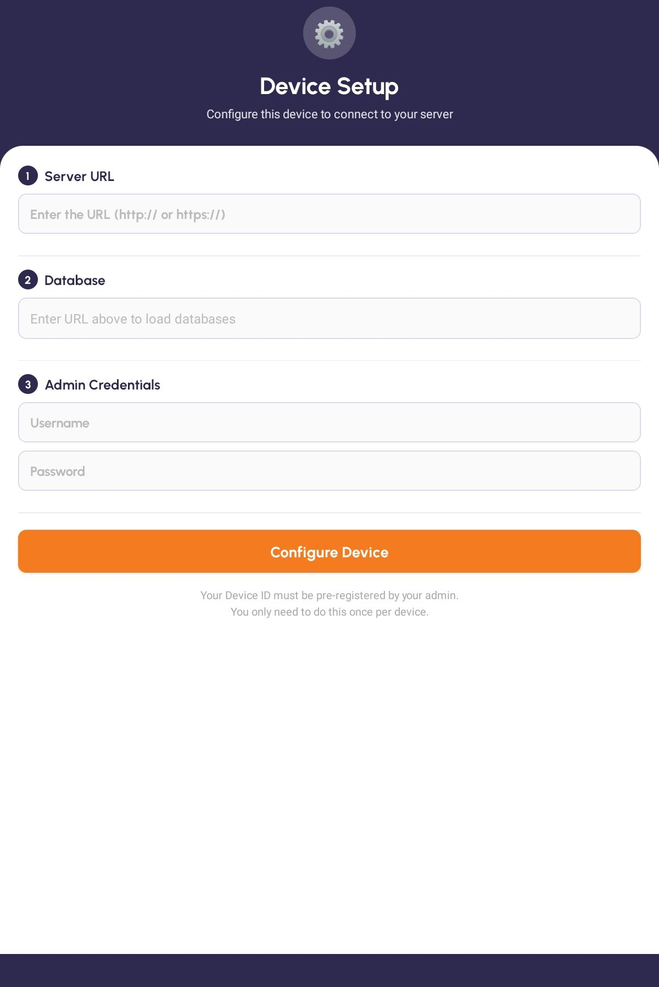
Device Setup — Server URL, the database picker and the admin credentials

Step 5 Pair by QR If the Tablet Is Not Recognised
If the tablet has not been pre-registered, Configure Device stops and offers you Scan QR. It also tells you exactly what to do: “Ask your admin to open Device Registry → New Device — a QR code will appear. Then tap Scan QR below.”
Tap Scan QR and point the camera at the code on the Odoo screen. The status line runs from “Point camera at the QR code on the Odoo screen” through “QR detected — registering device…” to “Device registered! Redirecting…”, and the tablet lands on the sign-in screen.
TIP The QR code deliberately does not carry the server address — only the database and the record. The address is the one you typed on Device Setup. That is what stops a tablet being paired to localhost and then failing everywhere else in the building.

Step 6 Getting Back to Device Setup Later
Once a tablet is set up, Device Setup is hidden. To reach it again — to move to a new server, or after the restaurant changes network — tap the "Welcome Back" title seven times on the sign-in screen. A gear appears in the top-right corner; tap it and you are back on Device Setup.
The taps must be brisk. Leave more than about three seconds between two of them and the count starts again.
IMPORTANT It is hidden on purpose, so that ordinary staff cannot repoint the tablet at the wrong server by accident. Treat it as a technician's gesture and keep it out of Book One.

PART 3 PRINTING

Step 7 How the App Decides Where to Print
There are two printing arrangements, and the app picks between them from your server address alone. Nobody chooses this on a settings screen.
Your server address | What happens | What has to be true
A local network address | Odoo talks to the printers itself. | The server must be able to reach the printers.
A public address or a domain name | Odoo prepares the ticket and the tablet sends it to the printer. | The tablet must be on the same network as the printers, and must be the installed app, not a development build.

IMPORTANT This catches people out. If your Odoo is in the building but you typed a domain name for it on Device Setup, the app switches to the second arrangement — and printing then depends on each tablet's Wi-Fi rather than the server's. Use the local network address for an on-site server.

Step 8 Set the Printers Up in Odoo
Printers are configured entirely in Odoo. There is no printer setup in the app — no pairing, no Bluetooth, no discovery, no printer list. Each printer is a record with these fields:
Field | What to set
Printer Name | Something you will recognise — Grill, Bar, Counter.
KOT IP and Port | The printer's network address. The port is almost always the default.
Type | Kitchen (KOT) for kitchen tickets routed by category, Receipt for the counter receipt, Invoice for a tax invoice, or Counter (Receipt + Invoice) for both.
Categories | Which product categories this kitchen printer takes. This is what sends grill items to the grill and drinks to the bar.
All in One KOT | Tick to send this printer the whole ticket rather than only its own categories.
Status | Read-only. Use Connection Test to check each printer answers; it reports each one as reachable or not.

TIP When staff report “No printer matched these items”, it is these Categories that are wrong. Every product category that can be ordered needs to be on at least one kitchen printer.

Step 9 What Each Document Is
Document | When it prints
Kitchen ticket | When staff tap Print Add-ons or Print Full Order. Goes to the kitchen printers that hold the relevant categories.
Receipt | Automatically, straight after a successful payment. Goes to the receipt or counter printer.
Invoice | Only where your server is set up to raise one. There is no invoice button on the tablet.

The restaurant name and country printed at the top of a receipt come from your Odoo company record, not from the app.

PART 4 CONTROLLING ACCESS

Step 10 The Three Controls
There are no user roles in the app. Everyone who can sign in sees the same screens and the same buttons. Three things control access instead, and all three are set on the server:
Control | What it stops
Device approval | An unapproved tablet never reaches the sign-in screen at all. Set per device in Device Registry — Step 3.
Payment PIN | Taking payment. Set once on the register in Odoo. Leave it blank and anyone can take payment.
Odoo user rights | Everything else. Standard Odoo access rules apply to whoever is signed in.

Action | What has to be true | Set where
Use the app at all | The tablet is Active, not Blocked | Odoo — Device Registry
Sign in | A valid Odoo username and password | Odoo — Users
Open or close a register | Nothing extra — anyone signed in can | —
Take an order | Nothing extra — anyone signed in can | —
Print to the kitchen | A kitchen printer covering those categories | Odoo — printer records
Take payment | The payment PIN, if one is set | Odoo — the register
Refund, void, report, reconcile | Not possible on the tablet | Odoo

IMPORTANT A blank payment PIN means no payment gate at all. If you want the gate, set the PIN. Changing it takes effect on the next order, with nobody signing out.

PART 5 WHAT BELONGS IN ODOO

Step 11 Jobs the Tablet Cannot Do
The tablet is built to be fast at the one thing a busy floor needs: take the order, feed the kitchen, take the money. Everything else is deliberately left to Odoo. Knowing the line saves your staff a lot of hunting through screens.
If someone needs to… | Where it happens
Reprint a receipt or an old kitchen ticket | Odoo. The tablet can only print the order it currently has open.
Refund, void or cancel an order | Odoo. A paid order opens read-only on the tablet.
Move, merge or split a table | Odoo. The floor plan seats and reopens; it does not rearrange.
Search orders, or look at another day | Odoo. The takeaway list shows the current session, with no search and no date filter.
Run any sales report, or a Z-report | Odoo. There is no reporting of any kind on the tablet.
Count the cash and reconcile the session | Odoo. Close on the tablet ends the session without counting it.
Split a bill across two payment methods | Odoo. One order, one payment method on the tablet.
Pick a product size, variant or option | Staff use the Note field. There is no variant or modifier picker, and a product with several variants will use its first.

IMPORTANT There is no offline mode. Every tap on the register goes to the server as it happens. If the network is down, the tablets cannot take orders — there is no queue that catches up later. Treat the Wi-Fi between the tablets and the server as service-critical.

PART 6 WHEN A TABLET WILL NOT SET UP

Step 12 Setup Messages, and What They Mean
What you see | What it means | What to do
Cannot reach server — check the IP address and port | The address is wrong, or the server is not running. | Check the address, and that the tablet is on the restaurant's network.
Connection timed out — is the server running? | The server was reached but did not answer. | Check the Odoo service is up.
Could not fetch databases — check the URL and try again | The address responded but not with a database list. | Confirm the URL, including the port.
Server found but database listing is disabled | The server will not list its databases. | A server-administration job.
Device Module Not Installed | The device module is missing on the server. | Install it — Step 1 — then run setup again.
Device Not Registered | This tablet has no record in Odoo. | Create one in Device Registry, then tap Scan QR.
Device Blocked | An administrator has revoked this tablet. | Unblock it in Device Registry, or use another tablet.
Server IP Changed? | The tablet was set up before, but is not found at this address. | If you have genuinely moved network, tap Update & Continue.
Invalid QR | The code is not a device-registration code. | Scan the code on the Device Registry form, not any other QR.
Cannot Reach Server during a scan | The tablet and the server are not on the same network. | Use the network address, not localhost.

QUICK REFERENCE — MANAGER

New Site Checklist
Order | Do this | Step
1 | Install the four modules on the Odoo server. | Step 1
2 | Name the presets and pricelists; tick Available in POS on the products. | Step 2
3 | Create a printer record per printer, set its Type and Categories, and run Connection Test. | Step 8
4 | Set the payment PIN on the register — or leave it blank knowingly. | Step 10
5 | Create a Device Registry record for each tablet. | Step 3
6 | On each tablet, run Device Setup using the local network address. | Steps 4, 7
7 | Sign in once on each tablet and take a test order end to end, including a print and a payment. | Book One

Things to Remember
▪ Name your presets with dine and take in them. Nothing else in Odoo will tell you this is why takeaway orders have gone missing.
▪ Use the local network address for an on-site server, or printing quietly becomes each tablet's job.
▪ A blank payment PIN means no payment gate at all.
▪ Blocked in Device Registry is the fastest way to retire a lost tablet.
▪ Every orderable product category must be on at least one kitchen printer, or its items will not print.
▪ Close on the tablet ends the session without counting the cash — reconcile in Odoo.
▪ There is no offline mode. The Wi-Fi between tablets and server is service-critical.
▪ Refunds, voids, reprints and every report are Odoo jobs. Tell your staff, so they stop looking.
Get the server named right, approve the tablets, point them at the local address, and the floor takes care of itself.

— End of Guide —
Alphalize | Restaurant POS User Guide

